4-BIT RIPPLE CARRY ADDER

**PROGRAM:**

module full_adder(in0, in1, cin, out, cout);

input in0, in1, cin;

output out, cout;

assign out = in0 ^ in1 ^ cin;

assign cout = ((in0 ^ in1) & cin) | (in0 & in1);

endmodule`

module ripple_carry_adder(in0, in1, out, cout);

input [3:0] in0;

input [3:0] in1;

output [3:0] out;

output cout;

wire c1, c2, c3;

full_adder fa0(in0[0], in1[0], 0, out[0], c1);

full_adder fa1(in0[1], in1[1], c1, out[1], c2);

full_adder fa2(in0[2], in1[2], c2, out[2], c3);

full_adder fa3(in0[3], in1[3], c3, out[3], cout);

endmodule

**#20**

**WAVEFORMS:**

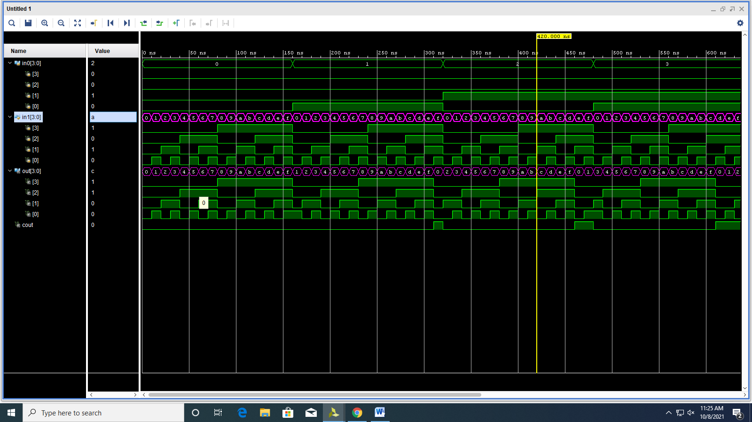

**RTL SIMULATION:**

